- Above New Customer/Current Customer, please add a heading that says "I am a:" I knew those fields were supposed to be there, but I completely overlooked them the first time I went to test the form.
- Make all section headers sentence case
- There's inconsistency in the way the fields are labeled in the Tell us about yourself section.
For example Name, Contact Phone, and Email address are the same hierarchical level as Address, city, etc, but Address and city labels appear formatted as First, Last, which are a sub-level below.
This is especially apparent on mobile.
- Some of the field groupings are inconsistently spaced when viewed on mobile. Here’s one example, but there are more:
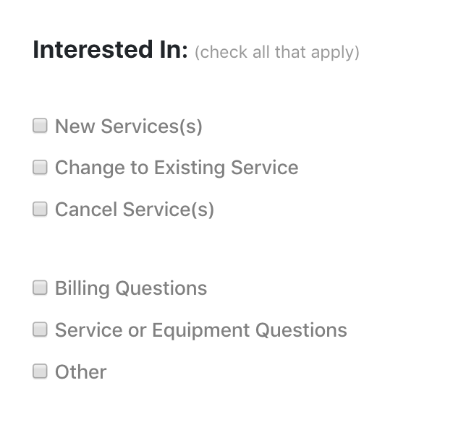
- Why have a dropdown field for State when Alaska is the only option?

